Package managers

Write Node program which transforms provided sentence to more artistic visual shape.

For this functionality you can use <https://www.npmjs.com/package/figlet> library (use NPM to download library).

Play around and figure out how to apply different font.

Input string: Hello World

Output string V1: 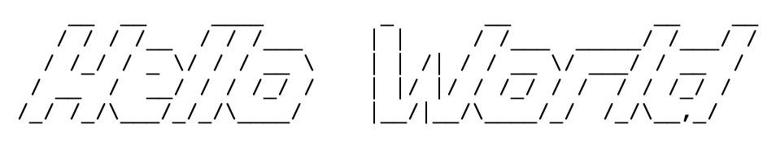

Output string V2:

